QUESTION 1-

Write a SQL statement to change the salary of an employee to 8000 whose ID is 105, if the existing salary is less than 5000

OUTPUT

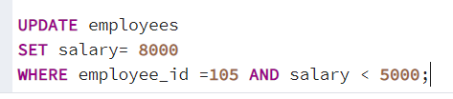

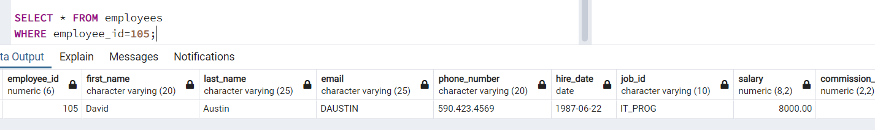

QUESTION 2-

Write a SQL statement to change the job ID of the employee which ID is 118 to SH_CLERK if the employee belongs to a department which ID is 30 and the existing job ID does not start with SH.

OUTPUT

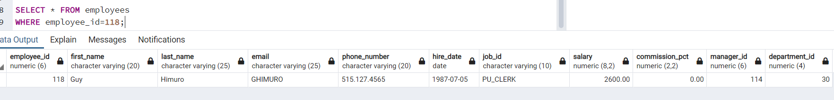

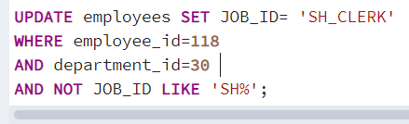



QUESTION 3

Write a SQL statement to increase the salary of employees under the department 40, 90 and 110 according to the company rules that, the salary will be increased by 25% of the department 40, 15% for department 90 and 10% of the department 110 and the rest of the department will remain same.

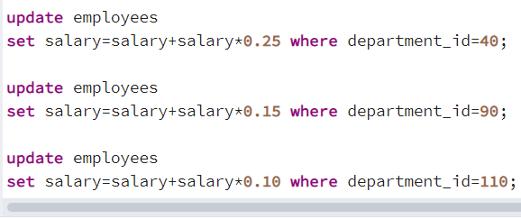







QUESTION 4

Write a SQL statement to change the email column of the employees table with 'not available' for those employees who belongs to the 'Accounting' department.

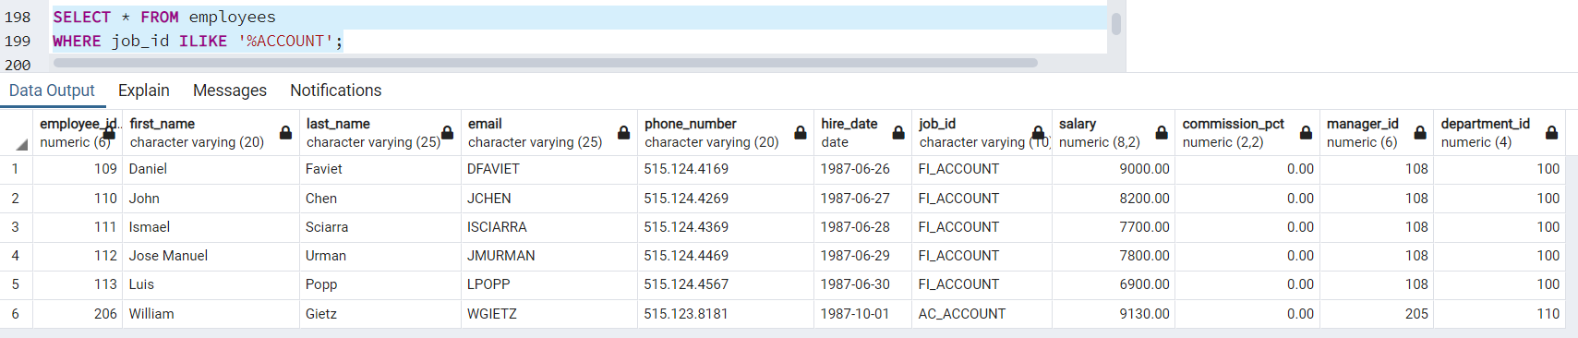

OUTPUT

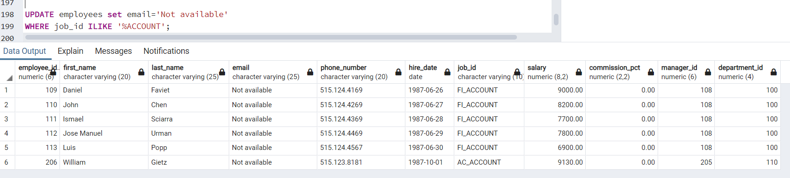

QUESTION 5

Write a SQL statement to change the email column of employees table with 'not available' for those employees whose department_id is 80 and gets a commission is less than.20%.

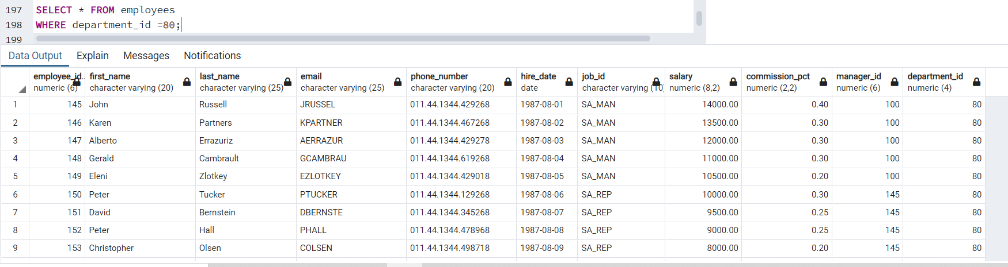

OUTPUT

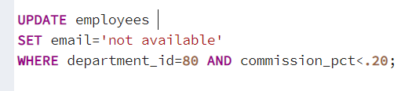

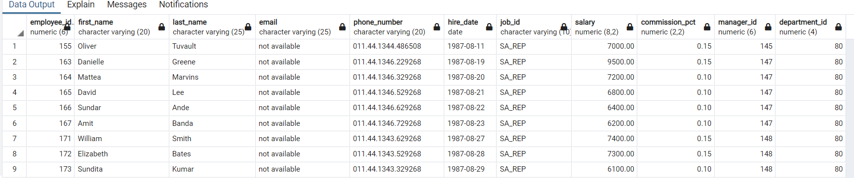

QUESTION 6

Write a SQL statement to change the email and commission_pct column of the employees table with 'not available' and 0.10 for all employees.

